**電通二乙微處理器實驗 實驗結報**

|  |  |  |  |
| --- | --- | --- | --- |
| **實驗名稱** | **Lab08-中斷控制與超音波測距** | | |
| **組別** |  | **組員** | **李仲朗04242456** |

1. **實驗目的**

Arduino於當按下Pin2外部中斷0時,讀入超音波測距之值顯示於PC上

1. 如何讀取超音波測距之值
2. 如何將超音波測距之值顯示於LCD上
3. Arduino如何規劃外部中斷INTO
4. 接一SW,當按下SW時暫停所有中斷,實驗結果又如何?

**1.實驗步驟**

**接電路**

**電路圖**

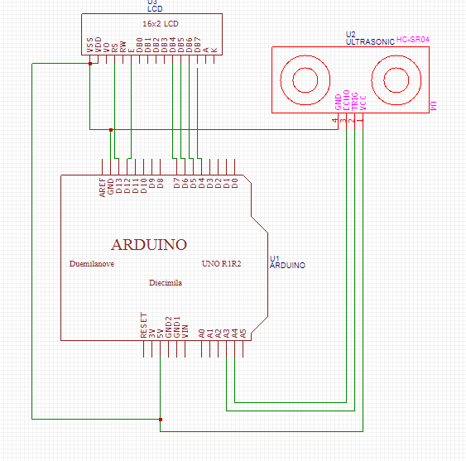

**程式碼**

**#include <LiquidCrystal.h>**

**#include <Ultrasonic.h>**

**LiquidCrystal lcd(15,14, 5, 4, 3, 2);**

**#define TRIGGER_PIN 12**

**#define ECHO_PIN 13**

**Ultrasonic ultrasonic(TRIGGER_PIN, ECHO_PIN);**

**void setup() {**

**lcd.begin(20, 2);**

**Serial.begin(9600);**

**}**

**void loop(){**

**float cmMsec, inMsec;**

**long microsec = ultrasonic.timing();**

**cmMsec = ultrasonic.convert(microsec, Ultrasonic::CM);**

**inMsec = ultrasonic.convert(microsec, Ultrasonic::IN);**

**lcd.setCursor (0,0);**

**lcd.print("MS: "); lcd.print(microsec);**

**lcd.setCursor(0, 1);**

**lcd.print(" CM: ");lcd.print(cmMsec);**

**lcd.print(",IN: "); lcd.print(inMsec);**

**delay(1000);**

**lcd.clear();**

**delay(100);**

**}**

**實驗結果及分析**

**讀取超音博測距值顯示在LCD上**

**2.**

**電路圖**



**程式碼**

**#include <LiquidCrystal.h>**

**#include <Ultrasonic.h>**

**#define TRIGGER_PIN 12**

**#define ECHO_PIN 13**

**volatile boolean state=LOW;**

**const byte intPin=6;**

**Ultrasonic ultrasonic(TRIGGER_PIN, ECHO_PIN);**

**LiquidCrystal lcd(15,14,5,4,3,2);**

**void setup() {**

**pinMode(6,INPUT);**

**lcd.begin(20, 2);**

**Serial.begin(9600);**

**attachInterrupt(intPin, int0, FALLING);**

**}**

**float cmMsec, inMsec;**

**long microsec;**

**void loop() {**

**if(digitalRead(6) == LOW) {**

**noInterrupts();**

**}**

**else {**

**interrupts();**

**}**

**Serial.print("MS: "); Serial.print(microsec);**

**Serial.print(", CM: "); Serial.print(cmMsec);**

**Serial.print(", IN: "); Serial.println(inMsec);**

**lcd.print("MS:"); lcd.print(microsec);**

**lcd.setCursor(0,1);**

**lcd.print("CM:"); lcd.print(cmMsec);**

**lcd.print(", IN:"); lcd.println(inMsec);**

**delay(1000);**

**}**

**void int0() { //interrupt handler**

**microsec = ultrasonic.timing();**

**cmMsec = ultrasonic.convert(microsec, Ultrasonic::CM);**

**inMsec = ultrasonic.convert(microsec, Ultrasonic::IN);**

**lcd.clear();**

**}**

1. **心得討論**

**這次實驗還挺好玩的,雖然一開始會手忙腳亂地,但還好最後有能做出來**